UNIT 2

Decision making structures require that the programmer specifies one or more conditions to be evaluated or tested by the program, along with a statement or statements to be executed if the condition is determined to be true, and optionally, other statements to be executed if the condition is determined to be false.
Following are the decision making statements
- simple – if statement
- if – else statement
- nested – if else statement
- else – if ladder
- switch statement

Simple – if statement
The ‘if’ keyword is used to execute a set of statements when the logical condition is true.

Syntax
if (condition){
Statement (s)
}
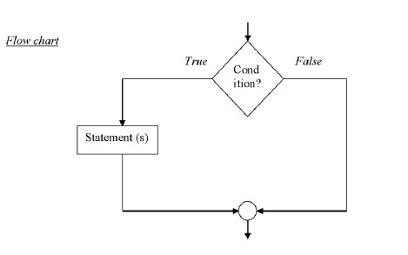
Example
The following example checks whether a number is greater than 50.
#include<stdio.h>
main(){
int a;
printf(“enter any number:
”);
scanf(“%d”,&a);
if(a>50)
printf(“%d is greater than 50”, a);
}

Output
1) enter any number: 60
60 is greater than 50 .
2) enter any number 20
no output

The if else statement
The if –else statement takes either True or False condition.

Syntax
if (condition){
True block statement(s)
}
else{
False block statement(s)
}

Flowchart
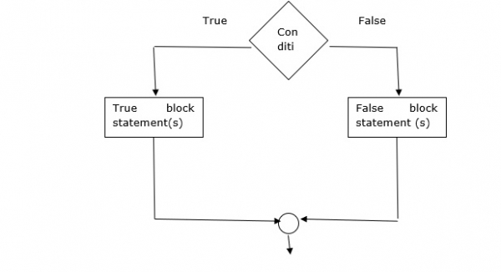

Example
Following is the program to check for even or odd number −
#include<stdio.h>
main(){
int n;
printf(“enter any number:
”);
scanf(“%d”,&n);
if(n%2==0)
printf(“%d is even number”, n);
else
printf(“%d is odd number”, n);
}

Output
1) enter any number: 10
10 is even number

Nested if - else statement
Here ‘if’ is placed inside another if (or) else −

Syntax
if (condition1){
if (condition2)
stmt1;
else
stmt2;
}
else{
if (condition3)
stmt3;
else
stmt4;
}

Flowchart
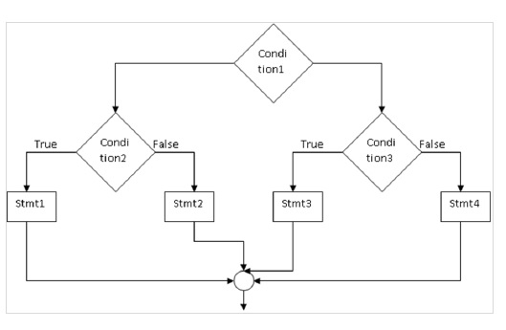

Example
Following example is to print the largest of 3 numbers from the given numbers −
#include<stdio.h>
main(){
inta,b,c;
printf(“enter 3 numbers”);
scanf(“%d%d%d”,&a,&b,&c);
if(a>b){
if(a>c)
printf(“%d is largest”, a);
else
printf(“%d is largest”, c);
}else{
if(b>c)
printf(“%d is largest”, b);
else
printf(“%d is largest”, c);
}
}

Output
enter 3 numbers = 10 20 30
30 is largest

Else – if ladder
It is a multi-way decision condition.

Syntax
if (condition1)
stmt1;
else if (condition2)
stmt2;
- - - - -
- - - - -
else if (condition n)
stmt n;
else
stmt x;

Flowchart
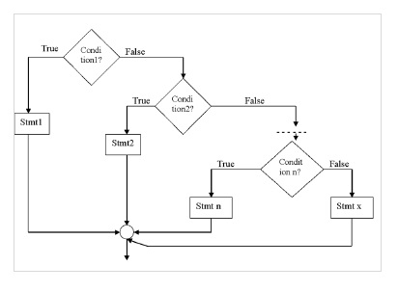

Example
Following example finds roots of quadratic equation −
#include<math.h>
main(){
inta,b,c,d;
float r1, r2
printf("enter the values a b c");
scanf(“%d%d%d”,&a,&b,&c);
d= b*b –4*a*c ;
if(d>0){
r1 =(-b+sqrt(d))/(2*a);
r2 =(-b-sqrt(d))/(2*a);
printf(“root1 ,root2 =%f%f”, r1, r2);
}
elseif(d==0){
r1 =-b /(2*a);
r2 =-b/(2*a);
printf(“root1, root2 =%f%f”, r1, r2);
}
else
printf("roots are imaginary”);
}

Output
1) enter the values of a b c : 1 4 3
Root 1 = -1
Root 2 = -3

Switch statement
It is helpful in selecting one among multiple decisions.

Syntax
switch (expression){
case value1 : stmt1;
break;
case value2 : stmt2;
break;
- - - - - -
default :stmt – x;
}

Syntax
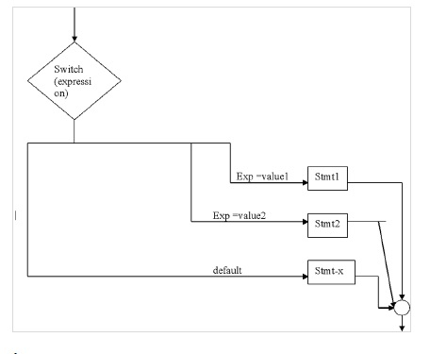

Example
#include<stdio.h>
main(){
int n;
printf(“enter a number”);
scanf(“%d”,&n);
switch(n){
case0:printf(“zero”)
break;
case1:printf(‘one”);
break;
default:printf(‘wrong choice”);
}
}

Output
enter a number
1
One

A while loop in C programming repeatedly executes a target statement as long as a given condition is true.

Syntax
The syntax of a while loop in C programming language is −
while(condition) {
statement(s);
}
Here, statement(s) may be a single statement or a block of statements. The condition may be any expression, and true is any nonzero value. The loop iterates while the condition is true.
When the condition becomes false, the program control passes to the line immediately following the loop.

Flow Diagram
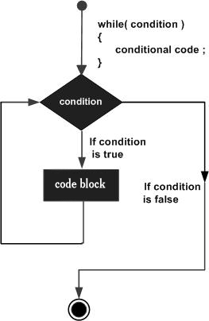
Here, the key point to note is that a while loop might not execute at all. When the condition is tested and the result is false, the loop body will be skipped and the first statement after the while loop will be executed.

Example
#include<stdio.h>

int main (){

/* local variable definition */
int a =10;

/* while loop execution */
while( a <20){
printf("value of a: %d\n", a);
a++;
}

return0;
}
When the above code is compiled and executed, it produces the following result −
value of a: 10
value of a: 11
value of a: 12
value of a: 13
value of a: 14
value of a: 15
value of a: 16
value of a: 17
value of a: 18
value of a: 19

Syntax
The syntax of a do...while loop in C programming language is −
do {
statement(s);
} while( condition );

Flow Diagram
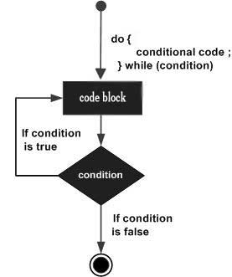

Example
Live Demo
#include <stdio.h>

int main () {

/* local variable definition */
int a = 10;

/* do loop execution */
do {
printf("value of a: %d\n", a);
a = a + 1;
}while( a < 20 );

return 0;
}

Output
value of a: 10
value of a: 11
value of a: 12
value of a: 13
value of a: 14
value of a: 15
value of a: 16
value of a: 17
value of a: 18
value of a: 19

The For Statement

The syntax of a for loop in C programming language is −
for ( init; condition; increment ) {
statement(s);
}

Flow Diagram
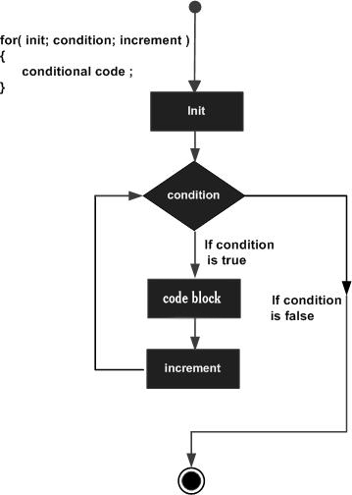

Example
#include <stdio.h>

int main () {

int a;

/* for loop execution */
for( a = 10; a < 20; a = a + 1 ){
printf("value of a: %d\n", a);
}

return 0;
}
Output

value of a: 10
value of a: 11
value of a: 12
value of a: 13
value of a: 14
value of a: 15
value of a: 16
value of a: 17
value of a: 18
value of a: 19

Jumps in Loops

Loop Control Statements
Loop control statements change execution from its normal sequence. When execution leaves a scope, all automatic objects that were created in that scope are destroyed.
C supports the following control statements.
Sr.No. | Control Statement & Description
1 | break statement  Terminates the loop or switch statement and transfers execution to the statement immediately following the loop or switch.
2 | continue statement  Causes the loop to skip the remainder of its body and immediately retest its condition prior to reiterating.
3 | goto statement  Transfers control to the labeled statement.

The Infinite Loop
A loop becomes an infinite loop if a condition never becomes false. The for loop is traditionally used for this purpose. Since none of the three expressions that form the 'for' loop are required, you can make an endless loop by leaving the conditional expression empty.
#include <stdio.h>

int main () {

for( ; ; ) {
printf("This loop will run forever.\n");
}

return 0;
}
When the conditional expression is absent, it is assumed to be true. You may have an initialization and increment expression, but C programmers more commonly use the for(;;) construct to signify an infinite loop.

